# Story board for user searching player and viewing report

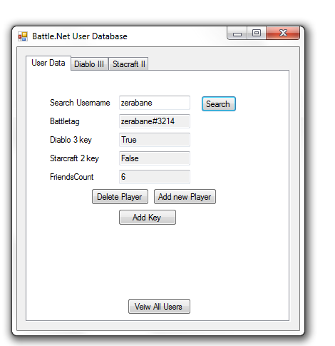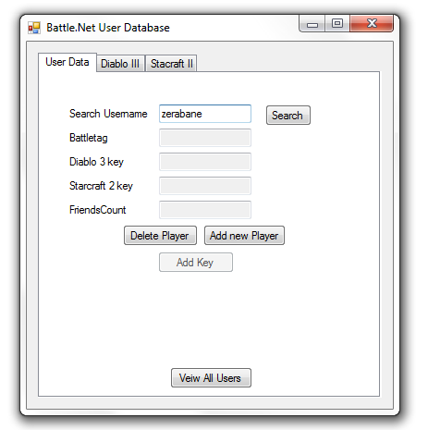1:On the first user enters a player’s name and 2:data linked to username is populated and tabs enabled

clicks search

3: if player owns game key the tab will be enabled and 4:User selects an option from the dropdown and

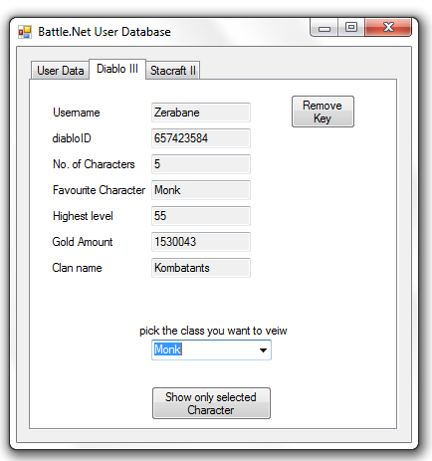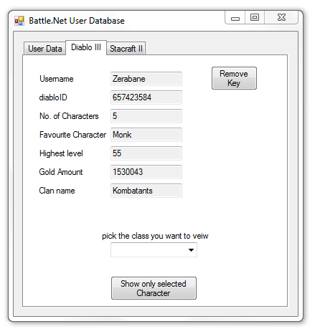 Fields populated 5:Clicks the show only selected character button

6:All users fitting the criteria are shown in the report 7:user clicks remove key button to remove their diablo 3

And clicks close window account

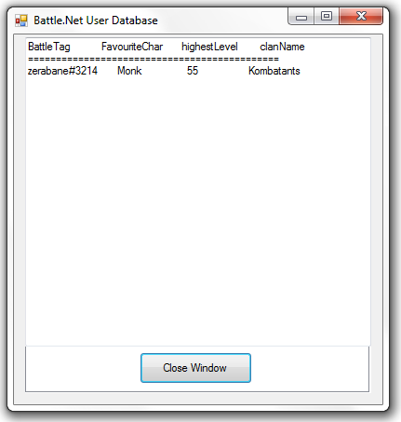

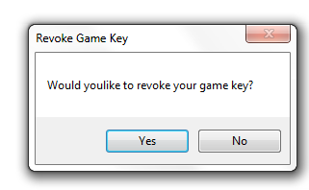 8:When prompted to remove key user clicks yes 9: the users account has remove the diablo 3 key and

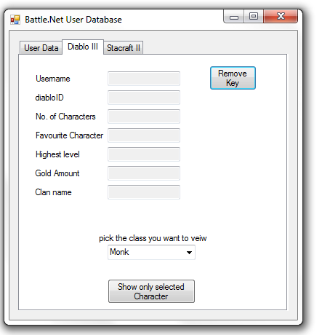 all fields therein